**Yifeng Huang**

**ART101 - Programming for the Arts 2024 Spring Quarter**

**Lab 6 Arrays and Objects 4/26/2024**

**Links to the lab assignment result**

Home Page: <https://yhuan359.github.io/art101>

This Lab page: <https://yhuan359.github.io/art101/lab6/index.html>

**Summary of Efforts**

It’s great to learn about data types and variables for problem solving that can be applied to daily living and especially for coding. It provides a clear picture and steps for what the problem is and how to solve it step by step when creating the codes.

**Screenshots:**

**Task 1: JavaScript Arrays and Objects**

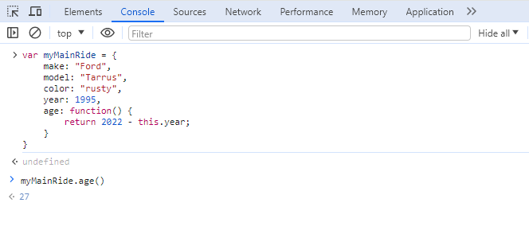

**Task 2: A JavaScript Program**

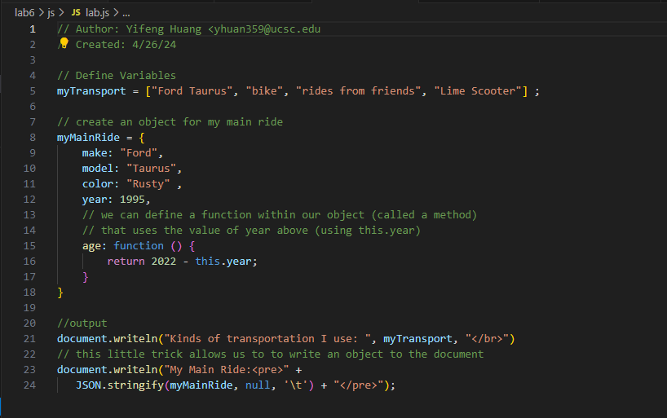

**Task 3: Create an index.html for Lab 6**

**Self-Evaluation Rubric**

|  |  |  |  |  |  |  |
| --- | --- | --- | --- | --- | --- | --- |
| Self-Evaluation Rubric | | | | | | |
| Did you complete the assignment and did you complete it on time? | Submitted on time | Up to 1 day late | Up to 2 days late | Up to 3 days late | Up to 4 days late | **Do you need to clarify?** |
| 口 | 口 | 口 | 口 | 口 | 1st submission was on-time. Resubmitted it with corrections 2 days later. |
| Did you collaborate with a partner? | A lot of effort |  | Some effort |  | Not this time | **Do you need to clarify?** |
| 口 |  | 口 |  | 口 |  |
| Did you put in earnest effort and provide an articulate summary of your experience? | Excellent | Pretty good | About average | Could be improved | Not this time | **What supports this?** |
| 口 | 口 | 口 | 口 | 口 | After studying this more, I feel I was able to improve in contrast to my previous assignments |
| Was the assignment complete, with minimal errors, correct output, and good style? | Excellent | Pretty good | About average | Could be improved | Not this time | **What supports this?** |
| 口 | 口 | 口 | 口 | 口 | My 1st submission did not meet what was required. The 2nd submission, I started over and corrected the mistakes |
| How much EXTRA effort did you put into the assignment? | A lot of extra effort |  | Some extra effort |  | Not this time | **What supports this?** |
| 口 |  | 口 |  | 口 | I had a second thought about what I should do to meet the requirements and re-did the assignment over again. |
| **Summary of your evaluation/efforts:** | | | | | | |
| It’s great to learn about data types and variables for problem solving that can be applied to daily living and especially for the coding. It provides a clear picture and steps what the problem is and how the solve it step by step when creating the codes. | | | | | | |